

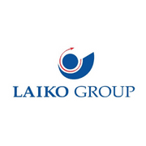

Laiko Group
The Laiko Group was established in 2002 following the merger of the companies Laiko Kafekopteio, LOEL and Printco, as well as their subsidiaries, creating one of the biggest Group of Companies in Cyprus. These companies are best known for the production of leading products such as Kafes Laikou, Elcafe, Zivana LOEL, Commandaria Alasia, along with many award winning wines and spirits, in addition to products in the categories of snacks, candies and baking products.
A significant part of the Group is an exclusive partnership for the sales and distribution of GREE air conditioners.
Today, The Laiko Group currently comprised of the following Companies:
1. Laiko Manufacturing and Trading Ltd
2. MasterStar Ltd
3. LOEL Viomichanoi
4. Laiko Holdings
5. Laiko Group
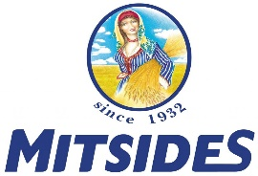

Mitsides Public Company
Apart from its main line of business which is the production and sale of flour and pasta, the company is also active in grain trading, the sale of pasta sauces, processed tomato products, frozen foods and other foodstuffs, as well as the sale of raw materials for the baking and confectionery industries.

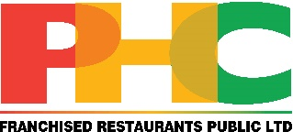

PHC Franchised Restaurants Public Ltd
PHC Franchised Restaurants Public Ltd was founded in 1991 and today is the largest company of Franchised Restaurants & Cafes in Cyprus representing top brands such as Pizza Hut, KFC, Taco Bell, Burger King, Wagamama, Caffè Nero, PAUL, Jamie Oliver Restaurants, as well as Local Restaurants & Cafés like Verde, Remezzo, Pier One, To Kypriakon, Tavernaki, and Catering services, Catercom.
PHC has more than 110 units all over Cyprus and Greece and employees 2500+ people.
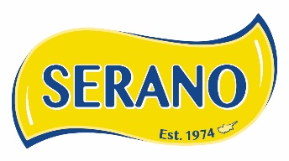

E.Neophytou Trading Ltd
Our company operates a state-of-the-art production facility specializing in the processing and packaging of high-quality dried nuts and dried fruits. With a strong focus on quality, innovation, and sustainability, we serve both domestic and international markets. Our products are exported worldwide, meeting the highest standards and satisfying the needs of partners and consumers across the globe.



PETROU BROS DAIRY PRODUCTS LTD
ALAMBRA has a big range of dairy products, like Halloumi cheese, Halloumi Light, Fresh and Dry Anari Cheese, Grated Cheese, Butter Ghee, Airani, Feta Cheese and many types of yoghurts.
Also Petrou Bros produce a range of products with a brand name “The Granny” with a big success in Cyprus and world market. “The Granny” products are Halloumi Cheese from 100% sheep and goat milk, Traditional Pure Yoghurt from 100% Sheep milk, Trahanas soup and Traditional Airani Drink from Sheep milk.
Furthermore in 2004, the company has started with great success importing cheeses from all over the world like Edam, Gouda, Mozarella, Kefalotyri, Feta, Parmesan, Milk and many other products.
During 2019, the company launched a new range of Product like Milk, Organic Milk, Goat’s Milk, Vegetable Drinks and Juices under ALAMBRA brand.
The product portfolio of PETROU BROS exceed 300 items.

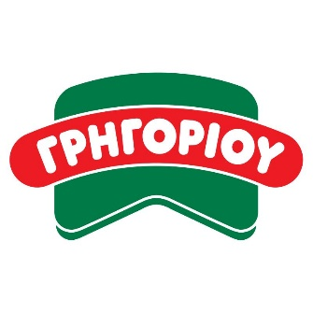

GRIGORIOU B.E. LTD

Grigoriou B.E. Ltd is engaged in the manufacture and trade of sausages and other meat products, since 1976. The center of the company's operations is its privately owned factory, located at the fourth kilometer of the Limassol - Paphos highway, which is also the distribution center of its products throughout Cyprus.
The production of all meat products takes place in the company’s factory, whose production capacity amounts to 20 tons per day.
The production unit is one of the most modern in Europe. In the facilities, which are equipped with state-of-the-art machines of the latest technology, under strict hygiene conditions and with the diligent work of a well-trained staff, which today reaches about 110 people, the unsurpassed GRIGORIOU products are being made.
Apart from a wide variety of European-style cold cuts, the tradition of the Grigoriou family in the production of traditional Cypriot products, continues. They are made with the exact same recipes used in the villages. What has changed is the strict and continuous scientific control.
The company implements 5 certified management systems: ISO 9001 for quality, ISO 22000 (HACCP) and FSSC 22000 for food safety, ISO 14001 for environmental management and ISO 45001 for occupational health & safety.
The faithful implementation of the above systems, the continuous quality control and the advanced program of modernization and automation of production and packaging, ensure the excellent and stable quality of the meat products produced by the company.

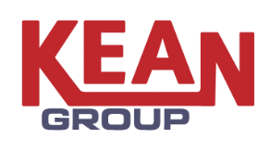

Kean Ltd
Η εταιρεία ασχολείται με την παραγωγή χυμών, φρουτοχυμών, αναψυκτικών και squash, όπως 100% χυμών, πολυβιταμινούχων, νέκταρ και φρουτοποτών, αναψυκτικών, Keanita, Vimto, Squash, παγωμένο τσάι και προιόντα ντομάτας, καθώς και Chilled 100% Juices . Η εταιρεία πέραν από τηΚυπριακή αγορά τροφοδοτεί άλλες 50 χώρες στην Ευρώπη, Ασία, Αφρική, Αμερική, Αυστραλία.

