


ISLAND SUSTAINABLE TOURISM ACTION THROUGH RESILIENT SMEs

I-STARS

OPEN CALL FOR APPLICATIONS

Grants Scheme for Tourism Businesses

ANNEX II
BUDGET FORM
(to be printed out, signed, dated and uploaded in PDF format)

Version 2.0
16 October 2023

Disclaimer
This publication is co-funded by the European Union. Views and opinions expressed are however those of the author(s) only and do not necessarily reflect those of the European Union or EIMSMEA - European Innovation Council and MSMEs Executive Agency. Neither the European Union nor the granting authority can be held responsible for them.
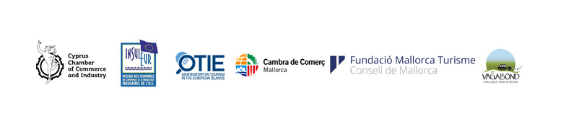

HISTORY OF CHANGES

Version | Publication Date | Change | Page
1.0 | 19.07.2023 | Initial version
2.0 | 16.10.2023 | Extension of deadline from 25/10/23 to 15/11/2023, 17:00 CET

How to submit YOUR BUDGET FORM
- Step 1: fill in the budget form below, sign and date it.
- Step 2: save your filled in budget form in PDF format.
- Step 3: submit your PDF budget form as an attachment to your online application form.

How much funding are you seeking? For each of the activities/services you are requesting to be funded, please specify activity details, the sustainability expert you have chosen, and the cost for acquiring the activity(ies).
SELECTED SERVICE/ACTIVITY | SPECIFY MILESTONE/DELIVERABLE OF SELECTED SERVICE/ACTIVITY  (e.g. Ecolabel certification, food waste audit, water conserving fixtures, etc.). Refer to ‘Guide for Applicants’, section 3.3.3 Eligible Activities. | Duration of implementation (mm/yy – mm/yy) | SELECTED SUSTAINABILITY EXPERT (name, telephone, email address) | COST  €
Sustainability certification scheme
Sustainability Strategy Plan(s)
Organisation Environmental Footprint
Tools/Software/Technology solution |  |  |  | (max. 20% of total grant amount)
Training & capacity-building activities |  |  |  | (max. 20% of total grant amount)
TOTAL COST OF ACTION |  |  |  | €
TOTAL AMOUNT OF REQUESTED GRANT |  |  |  | €
NOTE 1: applicants can apply for more than one of the above-listed activities. If the total cost of the action exceeds €5,600, then any extra costs will be co-financed by the applicant. The grant amount, however, cannot exceed €5,600.
NOTE 2: VAT is eligible only in the case it is non-deductible by the enterprise. In such a case, supporting evidence must be attached (Certificate or similar statement from the VAT authority of your country). If VAT is deductible, please exclude it from above amounts – double funding is strictly forbidden.

Company Name
Business address (street, city, country)
VAT number
Legal Representative (Name & Surname)

[Signature]

[Name & Surname of Legal Representative]

[Date]

